Thomas Sharkey – PRL Faculty Page

Research: Plant-Atmosphere Gas Exchange

The Sharkey lab studies the biochemistry and biophysics that determine the exchange of gases between the biosphere and the atmosphere. Currently our research is concentrated on three projects – (1) carbon metabolism of photosynthesis – from carbon dioxide uptake to carbon export from the Calvin-Benson Cycle, (2) isoprene emission from plants, and (3) abiotic stress tolerance. In addition to modern techniques such as engineering of transgenic organisms, studies of mutants, and various -omics technologies, our specialty is the use of gas exchange measurements to connect the gas exchange behavior of leaves with an understanding of biochemical and molecular mechanisms that determine plant growth and resilience.

Photosynthesis

Photosynthesis is the process by which energy from sunlight is captured and stored on carbon compounds. Carbon dioxide is taken up from the atmosphere, most often by diffusion. Changes in the carbon dioxide concentration in the atmosphere will have profound effects on photosynthesis (it already has). Carbon dioxide enters the Calvin-Benson cycle through the enzyme Rubisco. Carbon is processed in the Calvin-Benson cycle and then exported from the Calvin-Benson cycle to make starch, sucrose (table sugar) and many other end products.

We hypothesize that some of the carbon that leaves the Calvin-Benson cycle reenters the cycle through the glucose-6-phosphate shunt (see figure). As a result, carbon fixed by Rubisco is released in the oxidative branch of the pentose phosphate pathway. We hypothesize this improves resilience of the Calvin Benson cycle when light levels change rapidly (Sharkey & Weise 2016). We also hypothesize this explains the observation that the Calvin Benson cycle intermediates do not become 100% labeled when 13CO2 is fed to leaves.

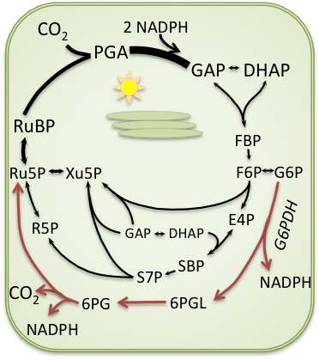*The glucose-6-phosphate shunt (in red). The Calvin-Benson cycle results in net fixation of carbon using the non-oxidative branch of the pentose phosphate pathway. The G6P shunt follows the oxidative branch of the pentose phosphate pathway and consumes three ATP but is balanced for NADPH and CO2. DHAP, dihydroxyacetone phosphate; E4P, erythrose 4-phosphate; F6P, fructose 6-phosphate; FBP, fructose 1,6-bisphosphate; GAP, glyceraldehyde 3-phosphate; R5P, ribose 5- phosphate; Ru5P, ribulose 5-phosphate; RuBP, ribulose 1,5-bisphosphate; S7P, sedoheptulose 7-phosphate; SBP, sedoheptulose 1,7-bisphosphate; Xu5P, xylulose 5-phosphate.*

*Photosynthesis is the source of nearly all of the material used in plant growth but the photosynthetic rate per leaf area does not explain many differences in growth rates of plants. The amount of dry matter per area of a leaf is a much better predictor of plant growth rate. Leaf mass per area is a measure of the investment of resources for a given amount of whole plant photosynthesis and also affects the respiration cost of making new photosynthetic leaf area (Sharkey 2015; Weraduwageet al. 2015; Weraduwage et al. 2016).*

By understanding the investments in photosynthesis and the relationship between plant growth parameters and photosynthetic rate, we hope to find ways to enhance plant growth and resilience, especially in light of a changing environment that could enhance photosynthetic rate because of increased CO2 but also reduce photosynthesis because of increased biotic and abiotic stress.

Isoprene

Isoprene emission from plants is the largest hydrocarbon input into the atmosphere, exceeding all of the inputs from human activities. Isoprene emitted from plants affects atmospheric chemistry. In polluted atmospheres isoprene can make ozone pollution worse. Even in unpolluted atmospheres it can contribute to aerosols that make a blue haze often seen in mountainous areas (thus Blue Ridge Mountains in Southeastern US, the Blue Mountains in Australia).

Despite the vast quantity of isoprene emitted by some plants, especially trees like oaks, poplars, and eucalypts, we still do not know why plants emit isoprene. There is some protection against abiotic stress such as high temperature and ozone as a result of isoprene production in plants but sometimes the effect is small and the mechanism is unclear.

Recently, we provided evidence that cast doubt on the two leading hypotheses, that isoprene (1) was modifying membrane properties or (2) was quenching reactive oxygen (Harvey*et al.*2015). But we also saw gene expression changes that were consistent with observations of colleagues using a different plant system (Behnke*et al.*2010). We hope to determine how isoprene can affect gene expression and how those changes in gene expression can improve plant resilience.

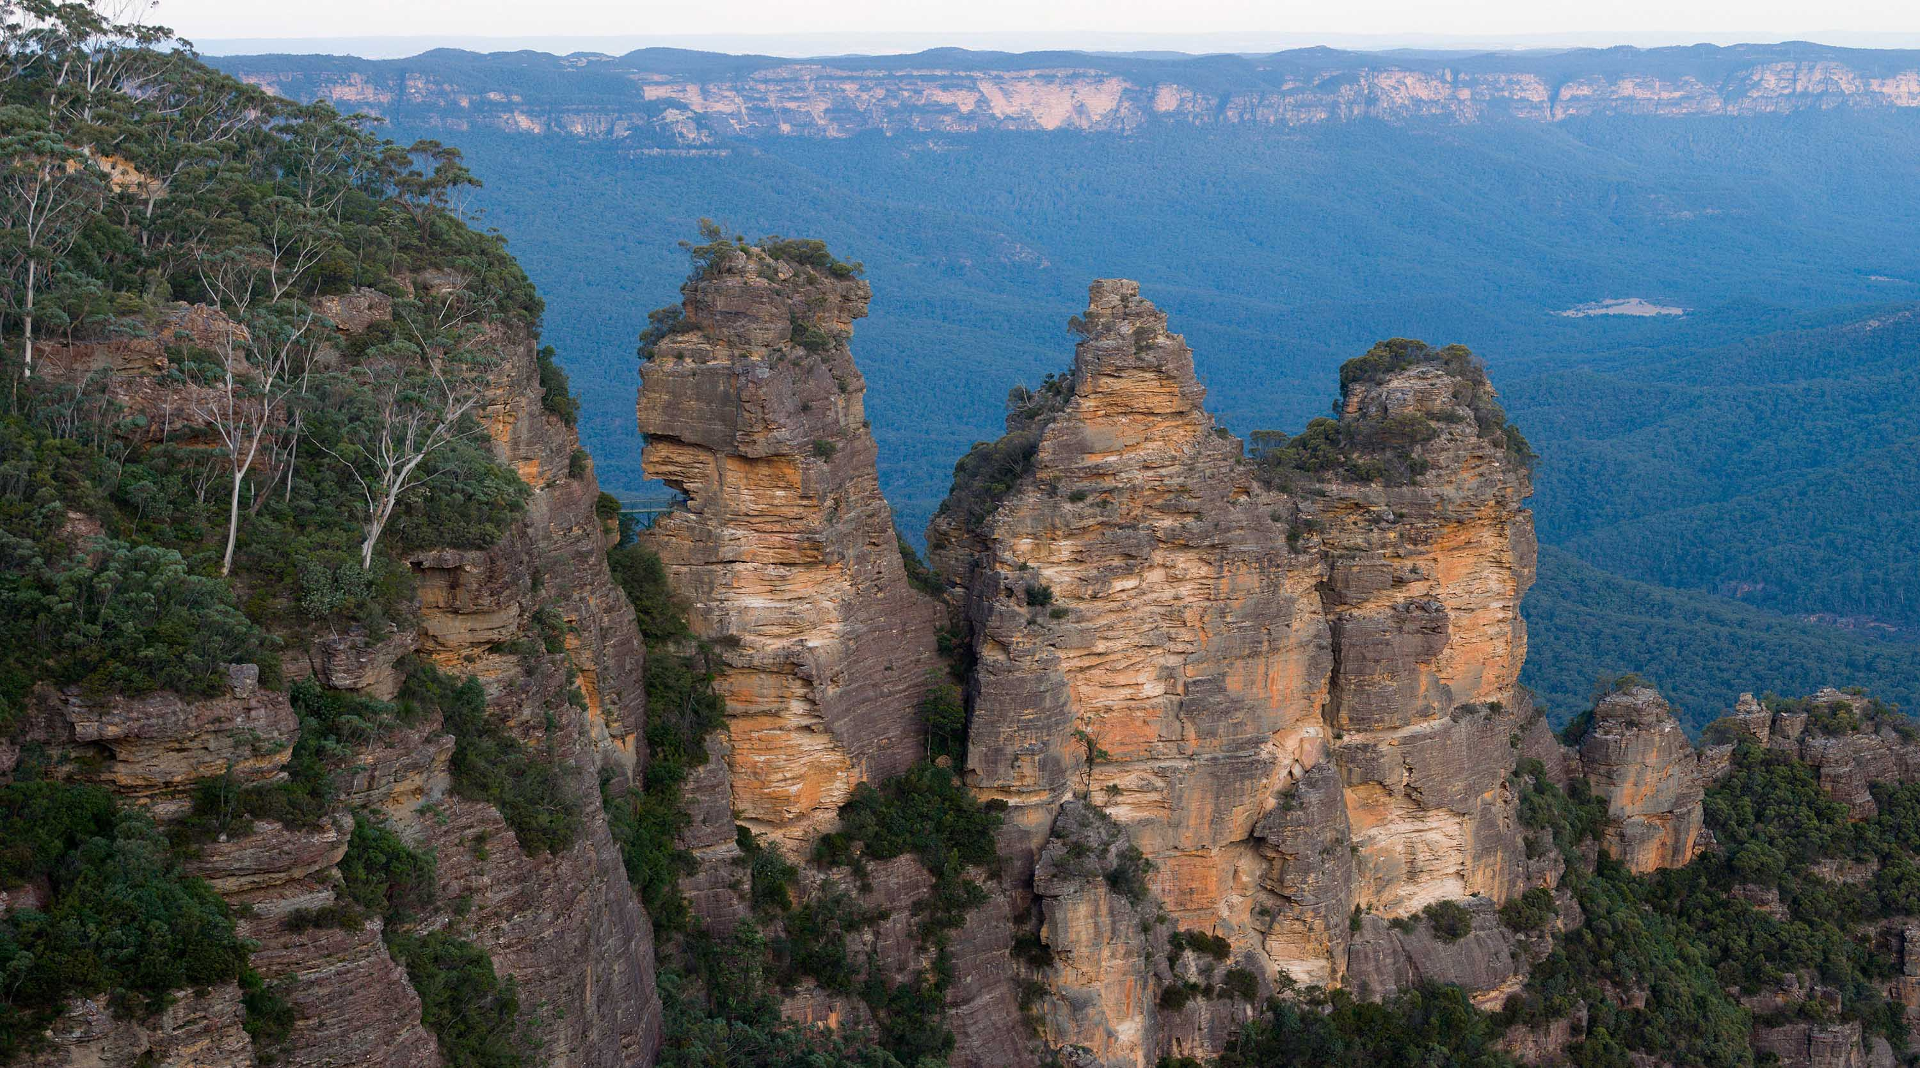*The Three Sisters rock formation in the Blue Mountains just outside of Sydney, Australia. Eucalyptus trees make a lot of isoprene. By Diliff,*[***CC BY-SA 2.5***](https://commons.wikimedia.org/w/index.php?curid=234811)

Isoprene emission is strongly stimulated by high temperature but is inhibited by high CO2. As a result, isoprene emission in the future is hard to predict. The CO2-inhibition may be related to carbon export from the Calvin-Benson cycle (called triose-phosphate-use, TPU). If so, CO2-inhibition of isoprene emission should be strongly temperature-dependent because TPU is strongly temperature dependent. We are using our expertise in understanding TPU to understand CO2 inhibition of isoprene emission and expect to inform global models predicting how isoprene emission will change in the future (it is very likely to go up).